Q1.
A company sells furniture to customers of its store. The store does not keep the furniture in stock. Instead, a customer places an order at the store and the company then orders the furniture required from its suppliers. When the ordered furniture arrives at the store a member of staff telephones or e-mails the customer to inform them that it is ready for collection. Customers often order more than one type of furniture on the same order, for example a sofa and two chairs.
Details of the furniture, customers and orders are to be stored in a relational database using the following four relations:

Furniture(FurnitureID, FurnitureName, Category, Price, SupplierName)
CustomerOrder(OrderID, CustomerID, Date)
CustomerOrderLine(OrderID, FurnitureID, Quantity)
Customer(CustomerID, CustomerName, EmailAddress, TelephoneNumber)

(a) These relations are in Third Normal Form (3NF).
What does this mean and why is it important that the relations in a relational database are in Third Normal Form?
Meaning: The fields in a 3NF table must tell a fact about the key, the whole key, and nothing but the key.
(2)

Why important: Because it prevents redundant data appearing or current data being duplicated.
(2)

(b) On the incomplete Entity-Relationship diagram below show the degree of any three relationships that exist between the entities.

 | Furniture |  | CustomerOrder
 | Customer |  | CustomerOrderLine

(3)

(Total 7 marks)

Q2.
A chef keeps her recipes on a single-table database system. Figure 1 shows the Recipe Table.
Figure 1
 | Recipe ID | Dish | Recipe Ingredients (including quantity) | Preparation Time | Cooking Time | Number of Servings | Cooking Instructions
 | 1 | Hummus | 250g chickpeas 6 cloves garlic 50ml lemon juice 340g tahini | 20 minutes | 2 hours | 8 | Cook chickpeas until soft. Puree in food processor. Add remainder of ingredients, mix well.
 | 2 | Feta Salad | 400g tomatoes 250g feta cheese 1 cucumber 50g olives 45ml vinaigrette | 15 minutes | none | 4 | Mix all salad ingredients together. Season with salt and pepper. Dress with vinaigrette.
 | 3 | Casserole | 500g chickpeas 400g tomatoes 450g potatoes | 10 minutes | 2 hours | 4 | Cook chickpeas until nearly soft. Add cubed potatoes and tomatoes........
 | : | : | : | : | : | : | :
 | : | : | : | : | : | : | :

The chef’s only supplier provides her with an on-line price list for her ingredients. Figure 2 shows the PriceList Table.
Figure 2
 | FoodItemID | FoodItemName | PackSize | Price
 | Tom001 | Tomatoes | 400g | £0.55
 | Chi002 | Chickpeas | 250g | £0.75
 | Cuc003 | Cucumber | single | £0.50
 | : | : | : | :

(a) (i) Which of the above two tables is not in First Normal Form? Figure 2
(1)
(ii) Why? All the fields rely on the FoodItemID key, and all tell a fact about it.
(1)

(b) The chef would like to be able to cost the ingredients for her dishes and is asking you to help her design a database which would allow the costing of dishes without retyping any of the pricelist details.
Database theory states that database tables should be fully normalised
(i) What does fully normalised mean?
All fields in the original table are separated so that each rely on only one primary key that is relevant to all fields.
(2)
(ii) Why is it desirable that tables are fully normalised?
To avoid the duplication of redundant data.
(1)

(c) When the data in Figure 1 and Figure 2 are stored in a fully normalised relational database, three relations, Recipe, FoodItem and RecipeIngredient are needed. For each of these, complete the relations, making sure the primary key attribute(s) are underlined.
(i) Recipe(Recipe ID, Dish, Recipe Ingredients, Preparation time, cooking time, Number of servings, cooking instructions)
(1)
(ii) FoodItem( Recipe ID, FoodItemID, FoodItemName, PackSize, Price)
(1)
(iii) RecipeIngredient(Recipe ID, Recipe Ingredients, FoodItemID, FoodItemName, PackSize, Price)
(4)

(Total 11 marks)

Q3.
An Examination Board records total entries by centre and subject for its examinations for June 2005 in an un-normalised relational database table as shown in the figure below. The data requirements specify that
• A subject offered for examination by the Examination Board has at most one Examination Board Subject Officer;
• An Examination Board Subject Officer may be a subject officer for more than one subject offered for examination by the Examination Board;
• Centre Number and SubjectID are unique.
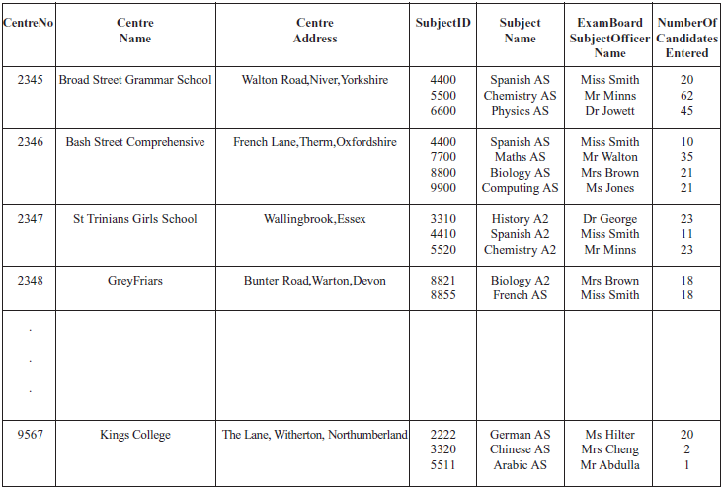

The relation for this table is as follows
ExamBoardEntryNumbers(CentreNo. CentreName, CentreAddress, SubjectID, SubjectName, ExamBoardSubjectOfficerName, NumberOfCandidatesEntered)
(a) What makes this table un-normalised?
Atomic data is stored with non-atomic data.
(1)

(b) When the data in the figure above is stored in a fully-normalised relational database three relations Centre, CentreEntryNumber and Subject are used. For each of these complete the relations making sure that the primary key attribute(s) are underlined.
(i) Centre (Centre No, Centre Name, Centre Address)
(2)
(ii) CentreEntryNumber (Centre No, ExamBoardSubjectOfficerName, NumberOfCandidatesEntered )
(2)
(iii) Subject (Centre No, Subject ID, SubjectName, NumberOfCandidatesEntered)
(2)

(c) (i) Complete the entity-relationship diagram for the entities Centre and CentreEntryNumber.

 | Centre |  | CentreEntryNumber

(1)
(ii) Complete the entity-relationship diagram for the entities Centre and Subject.

 | Centre |  | Subject

(1)

(Total 9 marks)

